MOVIE REVIEW WEBSITE

Table of Contents

Analysis 4

Outline of the problem 4

Stakeholders 4

How problem can be solved by computational methods 5

Conclusion 6

Research 7

Interview 7

Reviewing existing solutions 13

Google maps review system 13

Conclusion 16

Letterboxd 17

Conclusion 21

Hosting Options 22

Features of proposed solution 23

Limitations of proposed solution 25

Hardware and software requirements 27

Hardware requirements 27

Software requirements 27

Success Criteria 28

Design 29

Tables 29

Users 29

ReviewsRatings 29

Movies 29

MovieStarring 29

Actors 29

ER Diagram 30

Development 33

Testing 35

Evaluation 36

# Analysis

### Outline of the problem

I want to create a website that allows users to rate and review movies that they’ve watched and post it online for others to see. This allows users who are interested in certain movies to be able to get a general idea of the thoughts and opinions of the movie that they want to watch. This is a much more reliable system of spreading these thoughts about movies rather than relying on the word of mouth of others. The website will not only be limited to movies but also include TV shows and other forms of visual media. This website will be similar to existing websites like “letterboxd” and “IMDB”.

For this to work, the website should be very easily accessible and easy to navigate for users and should contain a very large database of movies for users to pick from which would be updated regularly so the latest movies are always available.

## Stakeholders

1. Sam Alfrey (Casual Movie Watcher) – Sam watches movies roughly once or twice a week and enjoys leaving movie reviews and ratings after he watches them. This makes him suitable to represent a casual movie watcher and users of the website that are interested in watching a movie or who have already watched a movie. The main uses for casual movie watcher are:
2. Find out whether a movie is good or bad and if it’s worth their time watching.
3. Spread their own personal thoughts and ratings of a movie they’ve watched.
4. Keep track of movies that they’ve watched.
5. Kitan Disu (Movie studio) – She used to create online content and release it publicly to the users so she’s a suitable to represent a movie studio that releases movies to the public. It would be very hard to get in regular contact with an actual movie studio to perform regular interviews so I’ve chosen an online creator to represent the average movie studio as she has experience with releasing content to the public and reading positive or negative feedback given which would be similar to the usage of the website for an actual movie studio. Movie studios that have released movies for users to watch can use the website to:  
   a. Gauge the general reaction and ratings to the movie.

b. View any criticisms that people have for the movie.

## How problem can be solved by computational methods

The problem can be solved very well through computational methods for several reasons:

**Website is easily accessible by users.**

The website is run on a server which means it can be accessed at any time and place by many users simultaneously as long as they have internet. This allows the problem to be a lot more accessible to users compared to word of mouth or a written system which can only be used by one user at a time and cannot be accessed at any location.

**Data is permanently stored in database.**

The reviews, ratings and movies watched will be permanently stored in a database which can be accessed at any time. This also means that the reviews can be as lengthy and detailed as possible which means they will be accurate as possible as spacing or storage on the database aren’t a concern. On the other hand, a movie review system through word of mouth or a written system would have many issues with storing a large number of lengthy reviews which will affect the accuracy of the reviews given. The data is also instantly stored in the database, so time is not wasted.

**The website is able to use algorithms.**

The website is also able to use algorithms to sort and filter results of different movies and results to help users search more effectively. The website is able to use algorithms to search through all the possible results and rank them based on specific criteria given. The website is also able to use algorithms to search through all the results and only display the results that fit a certain criterion. This reduces the time taken and difficulty for a user to search through results to achieve the correct result.

**Able to store information systematically and securely.**

The website allows each use to create and register their own accounts and store each user’s personal information in a secure database which can only be accessed by the website. All users’ data will be separate so any further reviews, ratings or movies watched can be allocated to that user’s account. This allows for data to be entered systematically and arranged in a way that makes it easy for the website to use algorithms to find and output necessary data. Furthermore, all the personal information is kept safe in the private database and secret from other users.

**The database can be updated regularly.**

The website uses a database to store its large list of movies. This list can be updated daily so that users are able to access the latest movies at any instance, this wouldn’t be possible using any other method such as word of mouth or a written method as there would be too much information for a person to record accurately and efficiently.

**The website is able to display videos and pictures.**

The website can be programmed so that pictures and trailers for each movie can be displayed on the overview on the movie so that users are able to get a general idea of what the movie is about. This isn’t possible using any other method other than computational methods.

### Conclusion

The previous examples have demonstrated that my problem can be solved well using computational methods compared to non-computational methods. Hence, the stakeholders are able to efficiently use the website to review, rate or log any movies that they’re interested in in a very efficient and effective way.

## Research

I regularly watch movies and enjoy leaving small reviews and ratings once I ‘ve watched them so I understand the problem very well and what features are essential for it to function properly and efficiently. I can also talk to my stakeholders to determine which features would be essential for the website’s usability from an outside perspective and determine how the website would be used and what additional features that would be required.

I can look at existing solutions to my problem to identify which features are useful and should be added to my own website.

### Interview

I’m able to get further feedback on what features are essential for the website to work properly by conducting several interviews on my stakeholders. I can ask a series of questions that can provide me with further insight to what people enjoy and dislike about a website like this which will give me a different perspective on this problem and its solutions.

I have prepared several questions that are used to draw out a user’s opinion on wide range of different aspects of the website. I have prepared two different sets of interview questions, one for each type of stakeholder since they both use the website for different purposes it only makes sense to ask two different sets of questions based on what they require from the website.

INTERVIEW 1 WITH SAM ALFREY

Transcript

ME: How often do you watch movies?

SAM: Not that often, probably around once a week maybe on a Friday night after school or sometime in the weekend.  
ME: How regularly do you log movies that you watch?

SAM: I review movies every now and then, only really if I find a movie particularly good or bad.

ME: How much do other people’s reviews affect your interest in a movie?

SAM: Quite a lot. If I see a lot of bad reviews on a movie, I probably won’t watch the movie but if I see a lot of good reviews on the movie, I’ll probably be more interested in watching it.

ME: How does a poor rating affect your interest of a movie?

SAM: It will definitely decrease my interest in a movie, but it really depends on how much I want to see the movie.

ME: How does a good rating affect your interest in a movie?

SAM: If I was already interested in the movie then it probably won’t affect my interest too much but if I previously wasn’t interested in the movie and I saw a lot of good reviews then it might make me interested.

ME: Do you regularly add movies to a watchlist if you’re interested in a movie?

SAM: Not so regularly but if there’s a movie that I’m especially keen on watching then I’ll add it to a watchlist.

ME: How important is a feature of creating a list of movies to you?

SAM: It’s not too important to me because I’m not that into organising and sorting all these kinds of stuff but I can still see it being useful to other people.

ME: Do you think that TV shows, documentaries and other forms of visual entertainment should also be included?

SAM: Yes, I think TV shows, documentaries should be included but maybe have like different categories for each of them so they’re not all under the same reviews.

ME: When using other existing websites, what are some of your biggest drawbacks from using the website?  
SAM: The biggest drawback for me I think is not knowing how the website works and it being really complicated to make simple reviews or ratings for a movie I’m interested in. If I really struggle with something like that then I’ll likely give up or try another website if I really can’t be bothered.

ME: When using other existing websites, what do you consider the most useful features?

SAM: The biggest feature is probably being able to like or dislike other people’s reviews to show that the review was helpful, and you agree with them.

ME: How does a paid membership affect your interest in the website?

SAM: Having a paid membership on a website usually makes me avoid it completely unless I’m really interested in it. So, it definitely decreases my interest in the website.

REVIEW OF INTERVIEW

From this interview I was able to determine what features the average user believes are essential and as well a different perspective on how the website should work.

The main takeaways from the interviews:

* The average user watches movies roughly once or twice a week and only logs them if they find it particularly good or bad.
* The reviews left on can potentially have great impact on other user’s interest of a movie.
* The average user isn’t willing to pay for a membership for the website and a paid membership would decrease their interest in using the website.
* One of the most useful features of a movie review website is the ability to upvote other reviews to help show that they are useful.
* TV shows, documentaries and other forms of visual media should be included on the website.
* The design of the website should be simple and easy to follow for new users.

INTERVIEW 2 WITH KITAN DISU

Transcript

ME: How does negative reviews on a project affect you?

KITAN: They make me want to make my videos better and more interesting so I try to take them as like constructive criticism but there are some which are just hate messages which I try my best to ignore.

ME: How does positive reviews on a project affect you?

KITAN: They make me want to make more videos and I like to listen to what people are interested in like if someone said that they liked a video about a certain topic then I would probably make more videos about that topic.

ME: How much value do you put on the reviews given to projects?

KITAN: I think the reviews are actually the most important thing because they come from all sorts of different places as they’re coming from people who are watching the project or who made the project with you and its important to listen to different perspectives on a project because they can help make it a lot better.

ME: How much value do you put on the rating given to projects?

KITAN: I would say it depends on where its from. Something I would suggest for the website is a feature where you’re able to see the quality of the person leaving the rating so if they’re someone who regularly hates on projects or someone who regularly leaves positive reviews, I think that that would help creators review the credibility of each rating to tell if its genuine or not.

ME: When using other existing websites, what are some of your biggest drawbacks from using the website?

KITAN: I would say the biggest drawback from using existing websites is that it takes a lot of effort to use the website and its core features like logging a movie review just take too much time to do. Also, for most of these websites you need to create an account to access most of the website which takes a lot of time and effort.

ME: When using other existing websites, what do you consider the most useful features?

KITAN: I think the most useful feature is where you’re able to see how credible a rating is which is really important to me and the ability to easily navigate between different ratings of projects so like when I’m going through my videos, I’m able to tell which video is rated the best and which is rated the worst.

ME: How does a paid membership affect your interest in the website?

KITAN: I would not use the website if I’m required to pay because there are so many free websites out there.

REVIEW OF INTERVIEW

From this interview I’m able to tell what features on the website is the most useful to movie studios and I’m able to gain an insight on how movie studios would most likely use the website and what aspects are most important to them.

The main takeaways from the interview:

* The reviews on projects can be very helpful towards creators as it helps them gain an insight to what is liked and disliked from their projects which they can use to improve their content.
* The reviews and ratings can be useful if a credibility system is put in place, so the creators know whether a review or rating is reliable or not.
* Ratings and reviews can help creators understand user’s perspectives and their opinions on their content.
* One of the biggest drawbacks from using existing websites is the amount of time and effort taken to use the website and its features and requirement to create an account to use the website.
* An essential feature for a creator would be the ability to navigate easily through different projects to help compare the performance of both projects.
* A paid membership would heavily decrease interest in the website.

## Reviewing existing solutions

### Google maps review system

The google maps review system.

Front page of google maps.

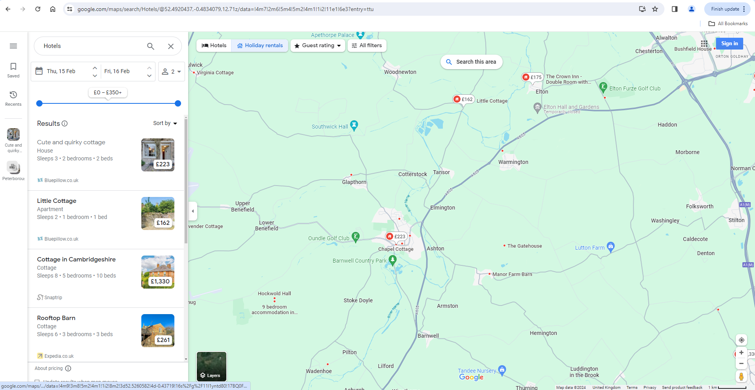

Search bar – to search up any locations.

Sign in – to sign into a registered account.

Results – to show all the results of the location that was searched up.

Sort by – to arrange all the results based on.

Filters – to help sort all results listed by only showing specific results based on criteria given.

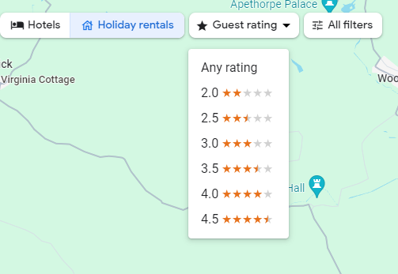Search by ratings

Guest rating – to search hotels based on specific ratings rather than actual ratings.

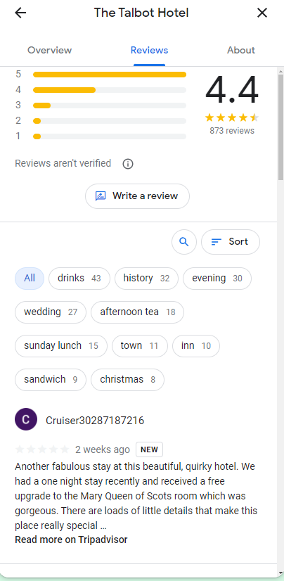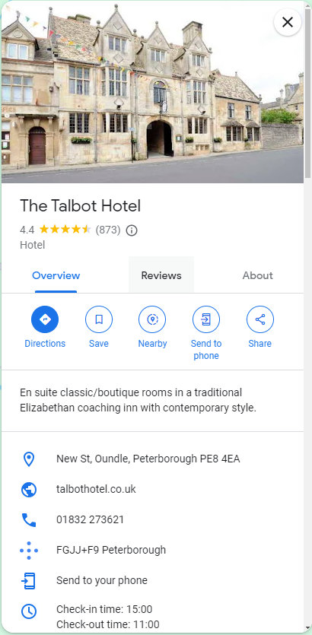Overview page

Rating – shows the average rating and the number of ratings given.

Overview – shows some information and rough details of the location searched up (exact address, website. Phone number etc)

Share – shares details about the location to other users.

Reviews page

Write a review – allows users to write a review and give a rating for the location.

Reviews – shows the distribution of ratings given by users.

Search – allows users to search through reviews given based on specific keywords.

Sort – arranges the results given by specific criteria given (most relevant, newest, highest rating, lowest rating)

Keywords – shows different keywords that users can use to filter the reviews given

Review page

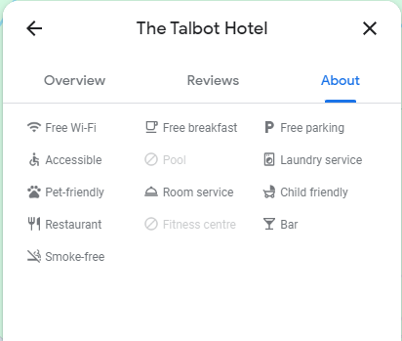About page

About – shows extra details about the location that the user should be aware about.

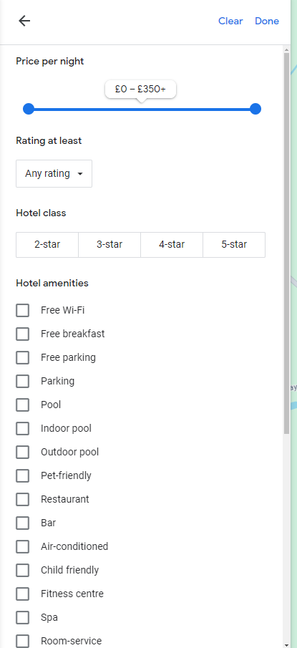Filter page

Rating at least – allows users to select a minimum rating for all the location results.

Hotel amenities – allows users to select certain criteria that the hotels would have.

Price per night – allows users to select the specific price range per night for the hotels.

### Conclusion

I believe that google maps has a really good review and rating system that I can take inspiration from as it contains many useful features that allows users to sort through and read reviews given as easily and effectively as possible. The problem I found with the review system is that it can be difficult to navigate the website and some of the features can be quite confusing and difficult to use for a beginner.

#### Letterboxd (https://letterboxd.com/)

Front page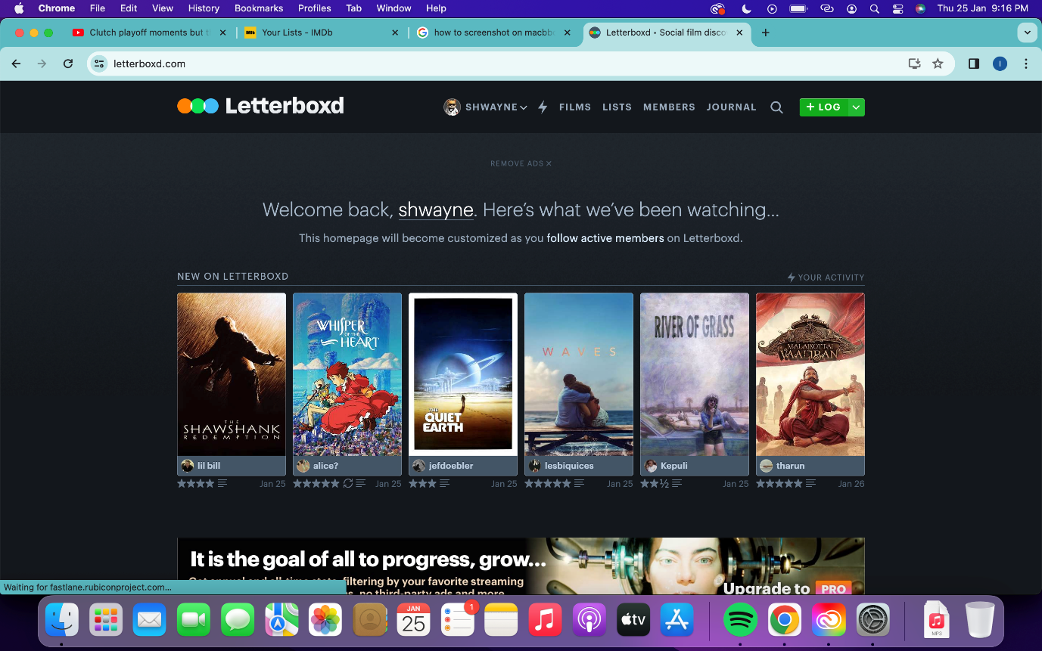

Letterboxd logo – when pressed, refreshes the page.

Sign in feature – to help users sign in so that their data is stored.

* With a dropdown menu that gives user access to additional settings

Films – to show films that are trending recently.

Lists – to bring users to the lists page, where users can create lists.

Journal – to bring users to journal page, where news about movies is shown.

Search – to search up any movie from the database.

log button – allows users to add new films that they’ve watched.

Header – contains menu feature and other links for easy navigation around website.

Log page

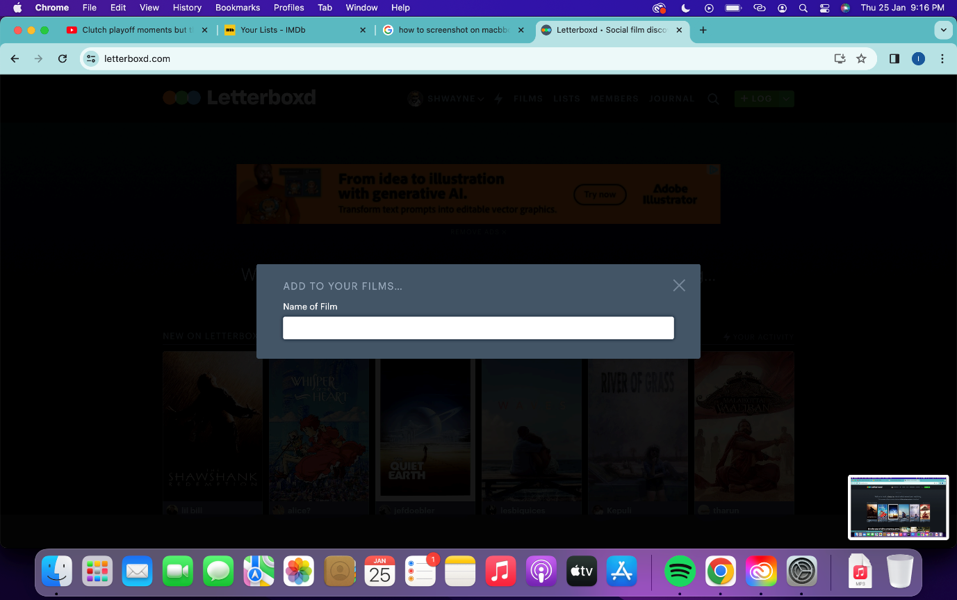

Search engine for users to search for the movie that they want to log.

Journal page

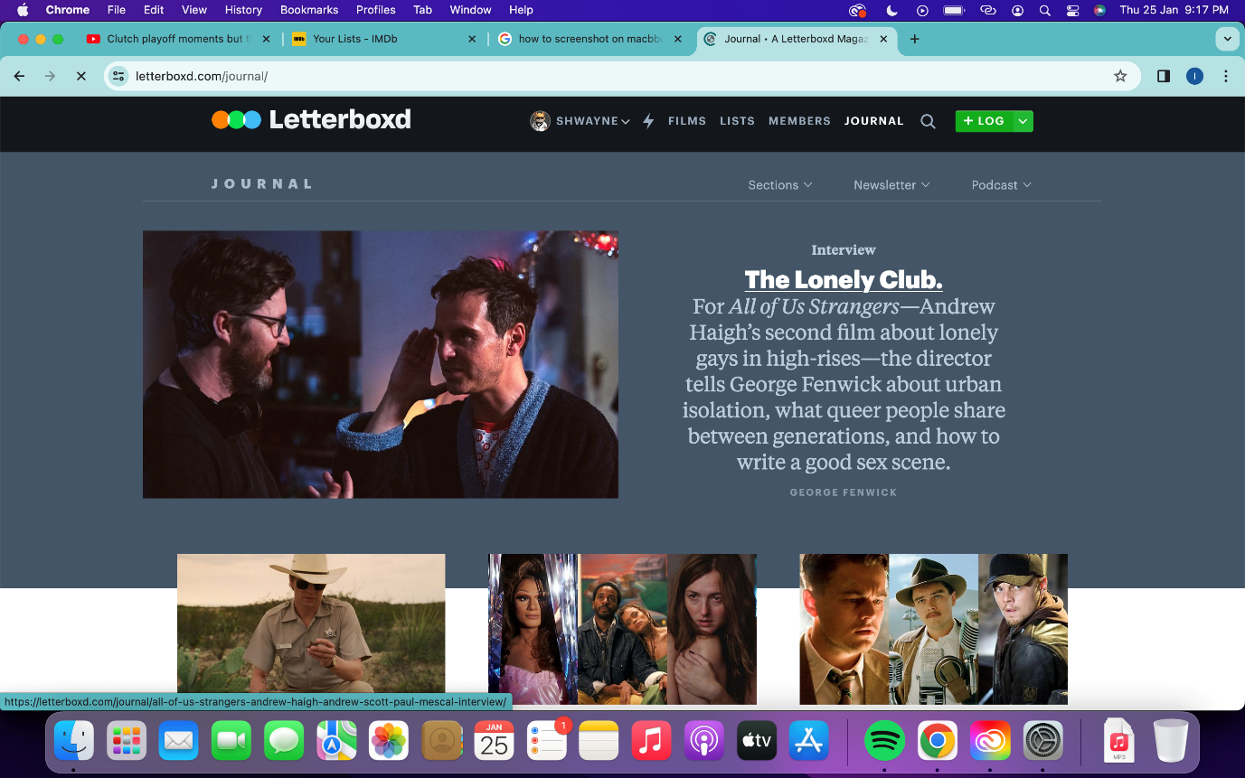

Journal page is essentially a news section for users to read about news relating to movies via actors, directors, movie studios etc.

Gives users a deeper insight into the behind-the-scenes actions of movies that they follow.

Lists page

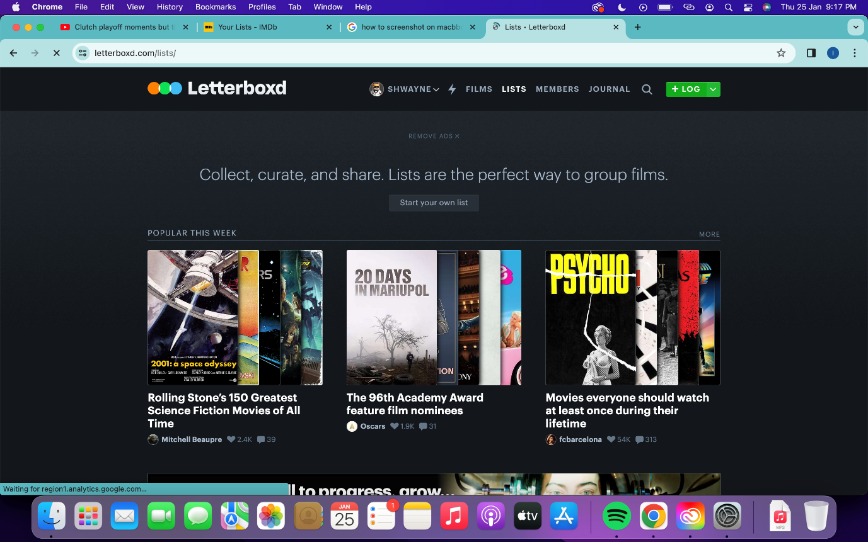

Feature for users to add movies or shows into a list and edit these lists.

Users are also able to view other users lists which are recommended to them bases on popularity.

Activity page

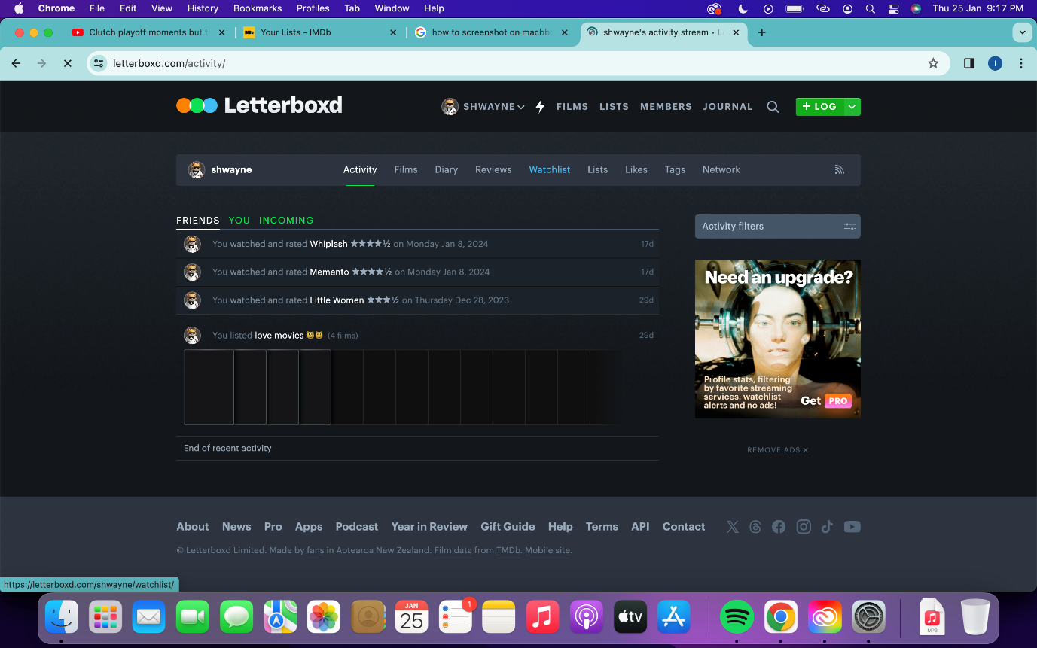

Shows users all previous activity on the website (reviews, ratings, lists etc).

Shows users all friends activity on the website.

* Allows users to check out friend activity on the website.

Allows users to filter the activity on the page to help show only relevant information.

Profile page

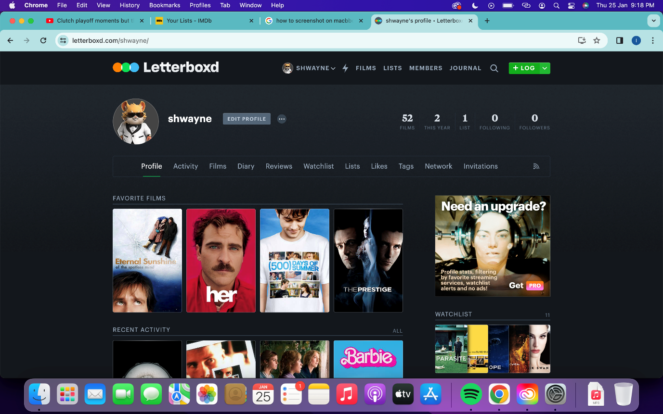

Edit profile button – allows users to customise what is shown on their profile and personalise other features (like their profile picture or username).

Allows users to look through all their interactions on their account (reviews, watchlists, likes, lists etc).

Feature that allows other users are able to view your profile.

Watchlist page

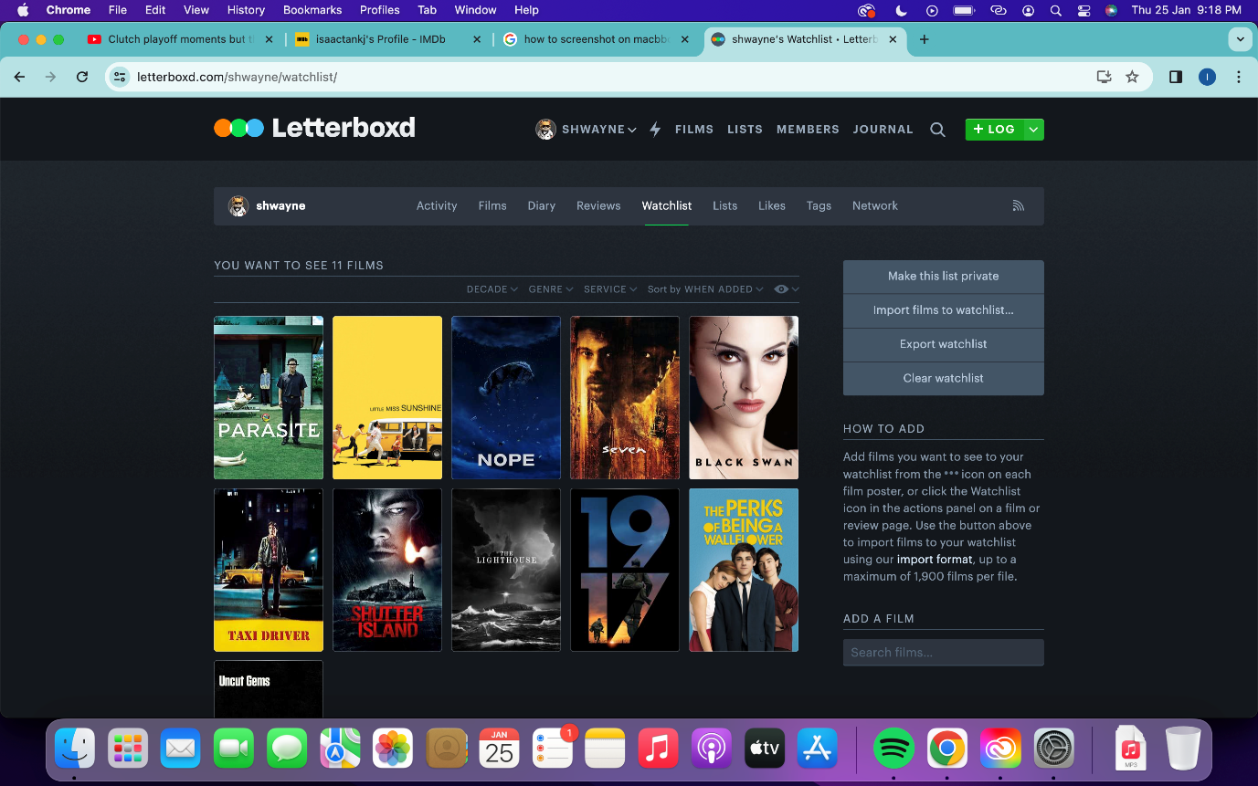

Shows users all the movies and shows added to their watchlists and automatically removes it once the user logs the movie, indicating that they’ve watched the film.

### Conclusion

I believe that there are many features that this website does quite well that I believe is essential for users, but I also believe that there are some excess features the website adds that makes it slightly complicated for new users to get used to. The layout of the website is simplistic and easy to navigate as a new user although sometimes the page feels very crowded as there are many buttons, links or ads surrounding the page from top to bottom. I would like for my website page to follow a similar design but focus more on being spacious and more simplistic to help with easy navigation and being user friendly.

### Hosting Options

According to TechRadar (<https://www.techradar.com/web-hosting/best-free-web-hosting>), InfinityFree is the best free webhosting provider available that offers 5GB disk spacing, unlimited domain hosting, unmetered monthly traffic and 400 MySQL Databases. The provider also offers unlimited websites, unmetered transfers and SQL.

<https://www.infinityfree.com/>

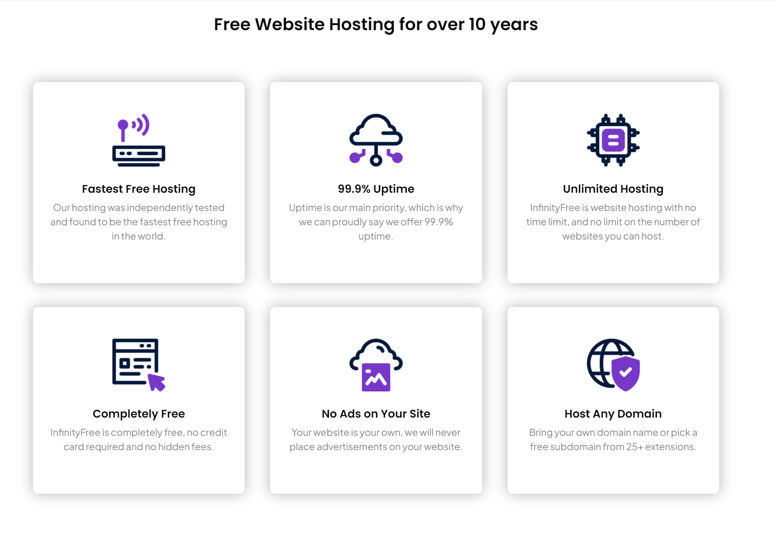

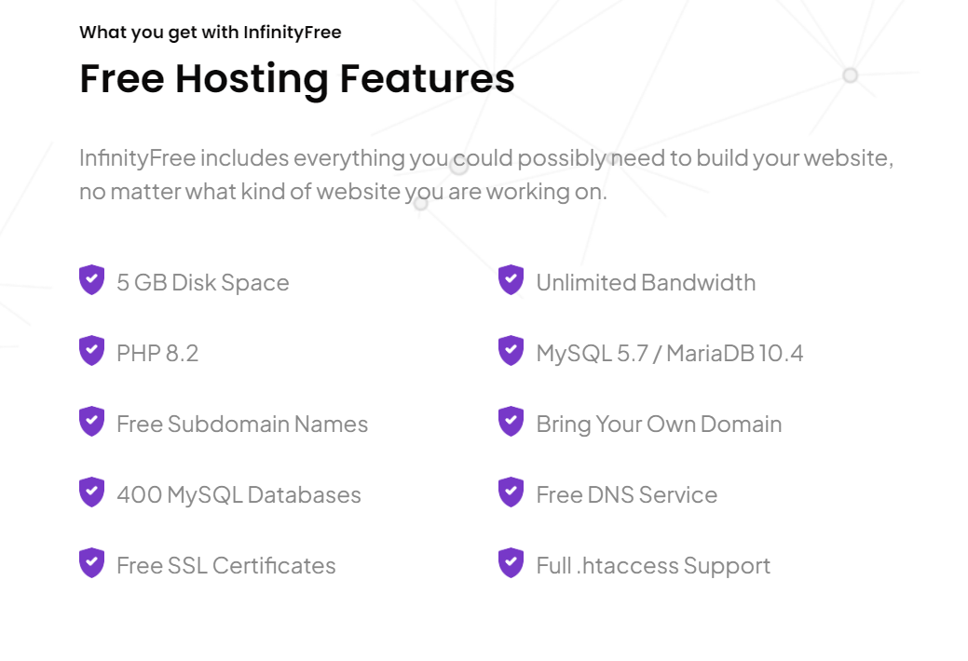

If after further development in the project I’m able to determine that the specifications of this webhosting provider is not sufficient to the website’s requirements then I will have to look further into paid webhosting providers and which option is the best. For the time being, I believe that this option is sufficient enough to use for the website and its database especially because I don’t have any funding for this project and the option is free of charge.

## Features of proposed solution

|  |  |  |
| --- | --- | --- |
| Feature | Purpose | Reasoning |
| Header, with links to different features | This helps users navigate and use the website easily (only main features are included in the header so that it doesn’t get crowded and is easy to understand for beginners) | This keeps the design of the website simple and easy to follow for beginners and the design of the website won’t be too crowded and filled with excess buttons and information. |
| Search bar | This is used to help users search through the database for the movies they’re interested in. The search bar should also include an autofill feature to help users select the movie they’re trying to fin. | This makes it easy and fast for users to find the movies that they they’re interested in. |
| Trailers | This shows the YouTube trailers for the movie. | This allows users to know what the movie they’re interested in is about. |
| Sign in | This is used so that users can store their data in their account (such as lists made, reviews/ratings given, or movies watched)  Users don’t need to sign in to view other people’s reviews but cannot leave reviews themselves unless they’ve signed in. | The reviews and ratings given must be associated with an actual user so that they have some credibility to them. Also, an account must be created so that the movie can be logged into that account’s viewing history. |
| Menu | This contains additional features for users which aren’t very important. | This keeps the design of the website simple and easy to follow for beginners and the design of the website won’t be too crowded and filled with excess buttons and information. |
| Recommend users movies to watch | This is used to give suggestions to users of similar type of movies based on their preferences. | This encourages users to watch more movies and read through more reviews and ratings which will increase the usage and activity on the website. |
| Watchlist | This is used to help users keep track of movies or shows that they’re interested in or want to watch | This encourages users to watch more movies that they’re interested in and want to watch in the future which will increase the user’s future activity on the website as well as making movie tracking easier for the user. |
| Lists | This is used for users to store movies in a list based on different genres which they can display on their profile for others to see. | This allows users show other users their favourite movies and their personal recommendations for movies of each genre. |
| Add reviews | This is for users to give their thoughts and opinions on a movie and for others to see the consensus of a movie is. | This helps users see if a movie is considered good or bad based on other users’ opinions and if it’s worth their time to watch the movie. |
| Add ratings | This is used for users to give their overall ranking of the movie from 1-10 and for others to see what the overall ranking is. (The overall rating is taken from average of all user ratings) | This helps users see if a movie is considered good or bad based on the overall rating given to the movie and if it’s worth their time to watch the movie. |
| Upvote | This is used to upvote a review of a movie to show that it was useful to the user. | This helps the website rank the movie reviews based on their relevancy and users will be more likely to see the more relevant and helpful reviews. |
| Buy tickets | This gives the users a list of possible websites where they can buy movie tickets for the movie, they’re interested in. This would be found in the overview of the movie. | If the reviews and ratings of a movie interest a user, then it makes it easier for users to book a ticket to watch the movie. This will encourage the user to watch the movie and increase activity on the website. |
| Credibility | This shows the amount of reviews a user has given and how long the user’s account has been created for. | This should give other users and movie studios an idea to how credible a specific rating or review is as an account that has been active for more time and has given more reviews will be more reliable. |
| Filters | This goes through the results and only shows the ones that fit the given criteria. Filters can be used for searching for movies or reviews. | This helps users find what they’re searching for more easily and quickly as it limits the number of results needed to look through. |
| Sort by | This sorts the results based on specific criteria like recency, relevancy, or rating. This can be used for searching for movies or reviews. | This helps arrange the data in a more effective and meaningful way so that it’s easier for the user to look through the results given. |

## Limitations of proposed solution

There are some limitations that must be considered for this project due to the ideas being either too farfetched or simply unrealistic for multiple reasons.

|  |  |  |
| --- | --- | --- |
| Limitations | Justification | Why is this a limitation |
| Social activity | This would allow users to add friends and other users on the website to view and share their activity. This would encourage more users to invite their friends to use the website and the user experience would be more enjoyable. | I believe that due to time limitations it is out of my programming ability and due to figure out how to program a social activity function where activity is able to be shared through the platform. I believe this feature also doesn’t relate much to the overall movie review aspect of the website and doesn’t add much in terms of functionality for the user. |
| Activity feed | This would show the user all their previous activity on the website which would encourage the user to add more reviews, ratings and movies. | I believe that the activity feed doesn’t add much to the website in terms of content or functionality for the user. Since I have a time constraint for this project, I believe it’s better to use the time and effort to add or polish more essential features that benefit the website. |
| News page | This would display all the latest news on movies, actors, directors, and anything related to movies in general. This would allow the users to be more informed about the latest movies and their favourite actors and directors. | I believe that it would require a lot of time and effort to implement a system to search through all news about movies and display them. Due to time constraint and the fact that a news page isn’t very essential to the functionality of the website, I don’t believe that it’s worth it to implement. |
| Paid membership | This would provide the user with an option to purchase a paid monthly membership that would provide additional features to the website and priority over regular users. | This would involve implementing a whole new set of features and benefits that would justify a paid monthly membership. It is also very difficult and time consuming to implement a transaction system especially when it isn’t essential to the functionality of the website. |
| Updating database instantly | The website would automatically and instantly update its database as soon as a new movie comes out so that users are able to access the latest movies as soon as possible. | There are so many movies being released every day that I don’t believe it’s worth it to implement a system where the database updates itself for every new movie. I believe that the server holding the database and the database itself would struggle to constantly be updating and inputting new data. It’s more worth it for the system to update everyday so that the data of all the new movies can be updated to the database all at once. |
| Listing every movie | The website would have a listing and information about every single movie that exists in the world. | There are so many small, local movies being released to the public that there is a high chance that these movies are overshadowed by bigger movies with a larger audience. This makes it very hard to implement a system to create listings for every movie that exists and is being released. No matter what is done there is likely to be some movies that will be left out. |
| Age restrictions | The website would require a user to enter their age when they create an account and would only let users view movies with a MPA film rating that matches their age. | This would likely deter users from using the website as they are unable to access the movie that they’re interested in and they will likely switch to a different website to fulfil their needs. It is also very hard to accurately prove the age of a user as birthdates entered can be faked. |

## Hardware and software requirements

### Hardware requirements

The users of the website don’t require any specific hardware requirements to use the website. Any standard device that is able to connect to the internet is able to access and use the website properly.

While developing the website I plan to run a local webserver using XAMPP until I finish developing the code properly to a finished state. I’m able to test the website

The final website should be by an external website that uses a server that has sufficient bandwidth, number of databases, uptime and storage space for the users to use the website efficiently and effectively. It’s difficult to determine the exact specifications that should be required until everything is implemented. It’s likely that the server would need to have decent specs to run properly as large amounts of data would be updated to the server daily due to new movies being constantly released.

### Software requirements

I’m able to develop the code for the website using Visual Studio Code as I’m very familiar with the program and its features. Visual Studio Code allows me to use HTML, CSS, JavaScript and PHP coding in the same platform which helps me to save a lot of time during the development stage of the website. I chose to write the program using these programming languages because I’ve done previous work on projects that are similar to this website using these programming languages so I’m familiar with them and able to use them to write code fittingly. I’m able to use XAMPP while developing my code to host the website locally on my computer to test its functionality as well as it provides me with a suitable Apache webserver with MySQL database and PHPMYADMIN. PHP can also connect to a MySQL database which pairs very well with XAMPP.

## Success Criteria

I’m able to judge whether my website is successful based on how well it is able to perform against these requirements.

|  |  |
| --- | --- |
| Requirement | Justification |
| The user is able to search up and access overview of movie within 90 seconds. | The user should be able to find the movie they’re interested in and access its information very quickly. |
| The user is able to add reviews up to 200 words successfully. | The user should be able to add reviews up to almost any length they desire so that they are able to freely express their thoughts and opinions about the movie for others to see. |
| The user is able to log 5 different movies they’ve watched. | The user should be able to log as many reviews as they desire. |
| The user is able to correctly sort and filter results using different criteria for both movies and reviews | The user should be able to use the sort and filter features for both movie results and the review results successfully. |
| The user is able to create an account within 5 minutes. | The user should be able to create an account for the website relatively quickly and easily as the user may lose interest in the website if it takes too long. |
| The user is able to successfully add and remove 5 different movies into a list. | The user should be able to create many different lists based on their personal preferences. The user should be able to add, remove or delete and lists that they’ve created. |
| The user is able to give ratings for 5 different movies. | The user should be able to write as many reviews as they desire for any movie they’re interested in. |
| The user is able to upvote 5 different reviews and then sort the reviews by relevance. | The user should be able to upvote comments to show that they’re helpful and relevant then after that sort the reviews based on how relevant they now are. |
| The user is able to successfully edit and save previous reviews and ratings submitted. | The user should be able to edit and save the changes made to any reviews or ratings that they’ve previously given at any point of time. |
| The website is able to recommend 3 different movies to the user based on preference. | The website should be able to access the user’s data and successfully recommend different movies that fit the user’s tastes based on their preferences. |
| The website is able to create a listing for the latest movie released. | The database for the website should be able to update itself with the information of the latest movie released and create a listing for the users to access on the website. |
| A new user should be able to successfully find essential features and identify their purpose. | The website’s design should be simple and easy to navigate so that new users don’t have trouble finding and identifying essential features. |

# Design

## Tables

### Users

|  |  |  |  |  |
| --- | --- | --- | --- | --- |
| Field Name | Data Type | Validation | Data example | Justification |
| UserID | INT(8) Primary Key | Must be exactly 8 digits (auto generated) | 12345678 | Unique identifier used for every user that registers an account for the website. |
| Forename | Varchar(20) | Must be 20 characters or less | Wayne | Used to identify users by their forename. |
| Surname | Varchar(20) | Must be 20 characters or less | Sng | Used to identify users by their surname. |
| Username | Varchar(15) | Must be 15 characters or less | waynesng98 | Used to identify different users. |
| Password | Varchar(50) | Required | password | Used so that only the user can access their registered account and information. |
| Email | Varchar(50) | Required | waynesng@gmail.com | Used to send user any important information about their account. |
| Gender | Varchar(1) |  | M | Used to identify user by their gender. |

### ReviewsRatings

|  |  |  |  |  |
| --- | --- | --- | --- | --- |
| Field Name | Data Type | Validation | Data example | Justification |
| UserID | INT(8)  Found from Users table | Must be exactly 8 digits (auto generated) | 12345678 | Unique identifier used for every user that registers an account for the website. |
| Username | Varchar(15) | Must be 15 digits or less | waynesng98 | Used to identify different users. |
| ReviewID | Varchar(18) | Required | 123456789abcdefghi | Used to uniquely identify different reviews. |
| ReviewData | Varchar() | Required | I believe this movie was very good and I enjoyed watching it very much. Would recommend for others. | Used to store all the data of the user’s review. |
| ReviewUpvote | INT(7) |  | 1000 | Used to help rank the reviews through the sorting algorithm. |
| RatingID | Varchar(18) | Required | 123456789abcdefghi | Used to uniquely identify different ratings and match the rating to the review given by the user. |
| RatingValue | FLOAT(1,1) | Required | 4.5 | Used to store the value of the rating given by the user. |
| MovieID | Varchar(18) | Must be exactly 18 characters (auto generated) | 123456789abcdefghi | Used to uniquely identify the movie in the database. |

### Movies

|  |  |  |  |  |
| --- | --- | --- | --- | --- |
| Field Name | Data Type | Validation | Data example | Justification |
| MovieID | Varchar(18)  Found from ReviewsRatings | Must be exactly 18 characters (auto generated) | 123456789abcdegfhi | Used to uniquely identify the movie in the database. |
| MovieAbout | Varchar() | Required | This movie is about a protagonist that goes on an interesting adventure and finds something interesting. | Used to store all the information and details about a movie which will be displayed in the about section. |
| MovieStarring | Varchar(5) | Required | 12345 | Used to help identify which actors star in the movie. |

### MovieStarring

|  |  |  |  |  |
| --- | --- | --- | --- | --- |
| Field Name | Data Type | Validation | Data example | Justification |
| MovieStarring | Varchar(5) | Required | 12345 | Used to help identify which actors star in the movie. |
| MovieID | Varchar(18) | Must be exactly 18 characters (auto generated) | 123456789abcdegfhi | Used to uniquely identify the movie in the database. |
| ActorID | Varchar(18) | Must be exactly 18 characters (auto generated) | 123456789abcdegfhi | Used to uniquely identify actors in the database. |

### Actors

|  |  |  |  |  |
| --- | --- | --- | --- | --- |
| Field Name | Data Type | Validation | Data example | Justification |
| ActorID | Varchar(18)  Found from MovieStarring | Must be exactly 18 characters (auto generated) | 123456789abcdegfhi | Used to uniquely identify actors in the database. |
| ActorForename | Varchar(20) | Must be 20 characters or less. | James | Used to identify actors by their forename. |
| ActorSurname | Varchar(20) | Must be 20 characters or less. | Blake | Used to identify actors by their surname. |
| ActorAge | INT(3) | Required | 45 | Used to identify the actor’s age and displayed for the audience. |
| ActorGender | Varchar(1) | Required | M | Used to identify the actor’s age and displayed for the audience. |

## 

## ER Diagram

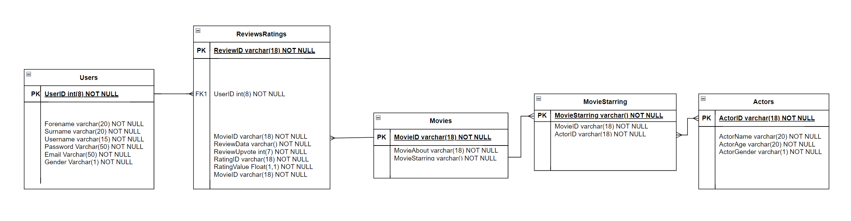Movie

## Top Down Diagram

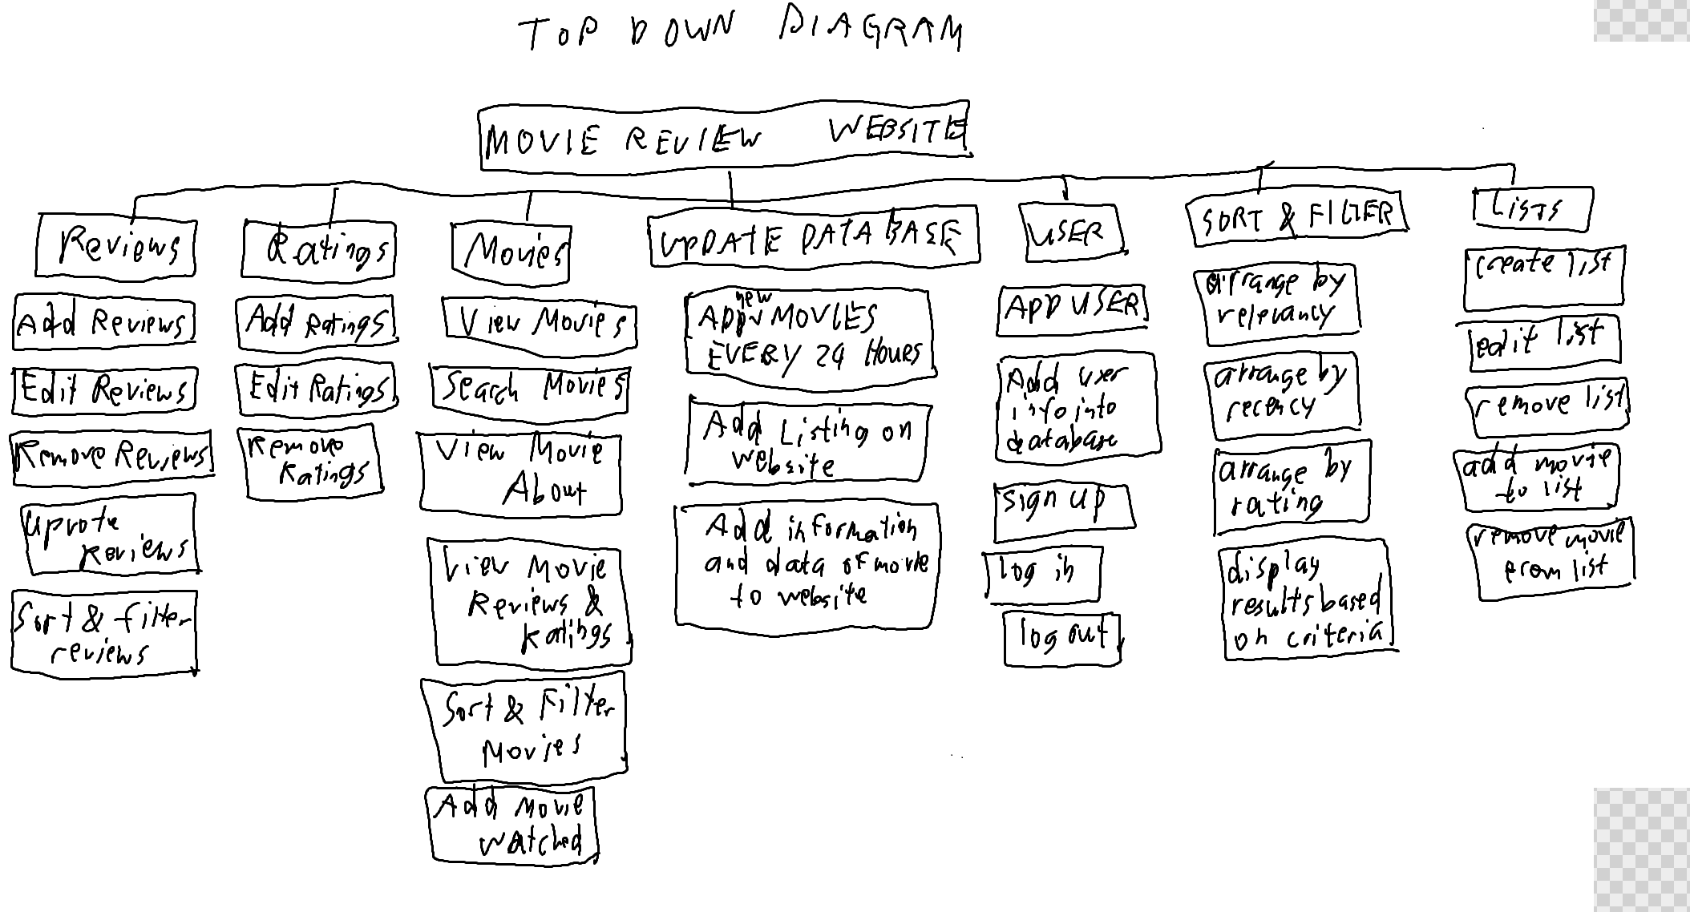

## 

# Development

# Testing

# Evaluation